Forecasting

You can forecast quantitative time-series data using exponential smoothing models in Tableau Desktop. With exponential smoothing, recent observations are given relatively more weight than older observations. These models capture the evolving trend or seasonality of your data and extrapolate them into the future. Forecasting is fully automatic, yet configurable. Many forecast results can become fields in your visualizations.

You can add a forecast to a view when there is at least one date dimension and one measure in the view. Choose **Analysis >Forecast >Show Forecast**. When no date dimension is present, you can add a forecast if there is a dimension field in the view that has integer values.

When a forecast is showing, future values for the measure are shown next to the actual values.

Forecasting Constraints

Forecasting is not supported for Multidimensional data sources. In Tableau Desktop, multidimensional data sources are supported only in Windows.

You can publish a view that contains a forecast, and see the forecast when you view or edit the view on the web, but you cannot modify or add a forecast when you are editing a view on the web.

In addition, you cannot add a forecast to a view if it contains any of the following:

* Table calculations
* Disaggregated measures
* Percent calculations
* Grand Totals or Subtotals
* Date values with aggregation set to Exact Date

# Forecasting When No Date is in the View

If a valid date is not in the view, Tableau will look for a dimension in the view that has integer values. If it finds such a dimension it will use that to forecast additional values for measures in the view. As with a date, when an integer dimension is selected to order the measures to be forecast, it is no longer used to partition the data. If there is more than one such integer dimension, Tableau will go in this order:

* An integer dimension on the Columns shelf. If there is more than one such dimension, it will use the first one (farthest to the left on the shelf).
* An integer dimension on the Rows shelf.
* An integer dimension on the Pages shelf.
* An integer dimension on the Marks card.

When Tableau is using an integer dimension to forecast, the Forecast Option and Forecast Description dialog boxes will automatically specify that forecasting is aggregating by periods:

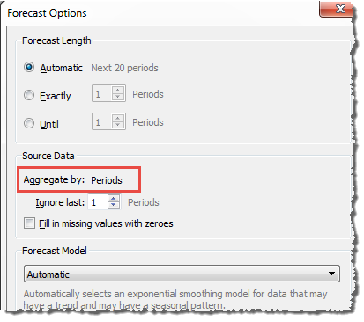

# How Forecasting Works in Tableau

Forecasting in Tableau uses a technique known as exponential smoothing. Forecast algorithms try to find a regular pattern in measures that can be continued into the future.

You typically add a forecast to a view that contains a date field and at least one measure. However, in the absence of a date, Tableau can create a forecast for a view that contains a dimension with integer values in addition to at least one measure. For details on forecasting using an integer dimension, see [Forecasting When No Date is in the View](http://onlinehelp.tableau.com/current/pro/desktop/en-us/forecast_no_date.html).

**In this article:**

* [Overview](http://onlinehelp.tableau.com/current/pro/desktop/en-us/forecast_how_it_works.html#Overview)
* [Exponential Smoothing and Trend](http://onlinehelp.tableau.com/current/pro/desktop/en-us/forecast_how_it_works.html#Exponential_Smoothing_and_Trend)
* [Seasonality](http://onlinehelp.tableau.com/current/pro/desktop/en-us/forecast_how_it_works.html#Seasonality)
* [Model Types](http://onlinehelp.tableau.com/current/pro/desktop/en-us/forecast_how_it_works.html#Model_Types)
* [Forecasting with Time](http://onlinehelp.tableau.com/current/pro/desktop/en-us/forecast_how_it_works.html#Forecasting_with_Time)
* [Granularity and Trimming](http://onlinehelp.tableau.com/current/pro/desktop/en-us/forecast_how_it_works.html#Granularity_and_Trimming)
* [Getting More Data](http://onlinehelp.tableau.com/current/pro/desktop/en-us/forecast_how_it_works.html#Getting_More_Data)

## Overview

All forecast algorithms are simple models of a real-world data generating process (DGP). For a high quality forecast, a simple pattern in the DGP must match the pattern described by the model reasonably well. Quality metrics measure how well the model matches the DGP. If the quality is low, the precision measured by the confidence bands is not important because it measures the precision of an inaccurate estimate.

Tableau automatically selects the best of up to eight models, the best being the one that generates the highest quality forecast. The smoothing parameters of each model are optimized before Tableau assesses forecast quality. The optimization method is global. Therefore, choosing locally optimal smoothing parameters that are not also globally optimal is not impossible. However, initial value parameters are selected according to best practices but are not further optimized. So it is possible for initial value parameters to be less than optimal. The eight models available in Tableau are among those described at the following location on the OTexts web site: [A taxonomy of exponential smoothing methods.](https://www.otexts.org/fpp/7/6)

When there is not enough data in the visualization, Tableau automatically tries to forecast at a finer temporal granularity, and then aggregates the forecast back to the granularity of the visualization. Tableau provides prediction bands which may be simulated or calculated from a closed form equation. All models with a multiplicative component or with aggregated forecasts have simulated bands, while all other models use the closed form equations.

## Exponential Smoothing and Trend

*Exponential smoothing* models iteratively forecast future values of a regular time series of values from weighted averages of past values of the series. The simplest model, *Simple Exponential Smoothing*, computes the next level or smoothed value from a weighted average of the last actual value and the last level value. The method is exponential because the value of each level is influenced by every preceding actual value to an exponentially decreasing degree—more recent values are given greater weight.

Exponential smoothing models with trend or seasonal components are effective when the measure to be forecast exhibits trend or seasonality over the period of time on which the forecast is based. *Trend* is a tendency in the data to increase or decrease over time. *Seasonality* is a repeating, predictable variation in value, such as an annual fluctuation in temperature relative to the season.

In general, the more data points you have in your time series, the better the resulting forecast will be. Having enough data is particularly important if you want to model seasonality, because the model is more complicated and requires more proof in the form of data to achieve a reasonable level of precision. On the other hand, if you forecast using data generated by two or more different DGPs, you will get a lower quality forecast because a model can only match one.

## Seasonality

Tableau tests for a seasonal cycle with the length most typical for the time aggregation of the time series for which the forecast is estimated. So if you aggregate by months, Tableau will look for a 12-month cycle; if you aggregate by quarters, Tableau will search for a four-quarter cycle; and if you aggregate by days, Tableau will search for weekly seasonality. Therefore, if there is a six-month cycle in your monthly time series, Tableau will probably find a 12-month pattern that contains two similar sub-patterns. However, if there is a seven-month cycle in your monthly time series, Tableau will probably find no cycle at all. Luckily, seven-month cycles are uncommon.

Tableau can use either of two methods for deriving season length. The original temporal method uses the natural season length of the temporal granularity (TG) of the view. Temporal granularity means the finest unit of time expressed by the view. For example, if the view contains either a continuous green date truncated to month or discrete blue year and month date parts, the temporal granularity of the view is month. The new non-temporal method, introduced with Tableau 9.3, uses periodic regression to check season lengths from 2 to 60 for candidate lengths.

Tableau automatically selects the most appropriate method for a given view. When Tableau is using a date to order the measures in a view, if the temporal granularity is quarterly, monthly, weekly, daily or hourly, the season lengths are almost certainly 4, 12, 13, 7 or 24, respectively. So only the length natural to the TG is used to construct the five seasonal exponential smoothing models supported by Tableau. The AIC of the five seasonal models and the three non-seasonal models are compared and the lowest returned. (For an explanation of the AIC metric, see Forecast Descriptions.)

When Tableau is using an integer dimension for forecasting, the second method is used. In this case there is no temporal granularity (TG), so potential season lengths must be derived from the data.

The second method is also used if the temporal granularity is yearly. Yearly series rarely have seasonality, but, if they do, it must also be derived from the data.

The second method is also used for views with temporal granularity of minute or second. If such series have seasonality, the season lengths are likely 60. However, when measuring a regular real world process, the process may have a regular repetition which does not correspond to the clock. So, for minutes and seconds, Tableau also checks for a length different from 60 in the data. This does not mean that Tableau can model two different season lengths at the same time. Rather, ten seasonal models are estimated, five with a season length of 60 and another five with the season length derived from the data. Whichever of the ten seasonal models or three non-seasonal models has the lowest AIC, that model is used to compute the forecast.

For series ordered by year, minute, or second, a single season length from the data is tested if the pattern is fairly clear. For integer ordered series, up to nine somewhat less clear potential season lengths are estimated for all five seasonal models, and the model with the lowest AIC is returned. If there are no likely season length candidates, only the non-seasonal models are estimated.

Since all selection is automatic when Tableau is deriving potential season lengths from the data, the default Model Type of “Automatic” in the Forecast Options Dialog Model Type menu does not change. Selecting “Automatic without seasonality” improves performance by eliminating all season length searching and estimation of seasonal models.

The heuristic that Tableau uses to decide when to use season lengths derived from the data depends on the distribution of errors for the periodic regression of each candidate season length. Since the assembly of season length candidates by periodic regression usually produces one or two clear winning lengths if seasonality actually exists in the data, the return of a single candidate indicates likely seasonality. In this case, Tableau estimates seasonal models with this candidate for year, minute and second granularity. The return of less than the maximum of ten candidates indicates possible seasonality. In this case, Tableau estimates seasonal models with all returned candidates for integer ordered views. The return of the maximum number of candidates indicates that errors for most length are similar. Therefore, the existence of any seasonality is unlikely. In this case, Tableau estimates only non-seasonal models for an integer-ordered or yearly ordered series, and only the seasonal models with a natural season length for other temporally ordered views.

For Model Type “Automatic” in integer-, year-, minute- and second-ordered views, candidate season lengths are always derived from the data whether or not they are used. Since model estimation is much more time consuming than periodic regression, the performance impact should be moderate.

## Model Types

In the Forecast Options dialog box, you can choose the model type Tableau users for forecasting. The Automatic setting is typically optimal for most views. If you choose Custom , then you can specify the trend and season characteristics independently, choosing either None, Additive, or Multiplicative:

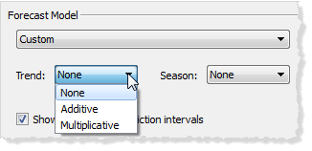

An additive model is one in which the contributions of the model components are summed, whereas a multiplicative model is one in which at least some component contributions are multiplied. Multiplicative models can significantly improve forecast quality for data where the trend or seasonality is affected by the level (magnitude) of the data:

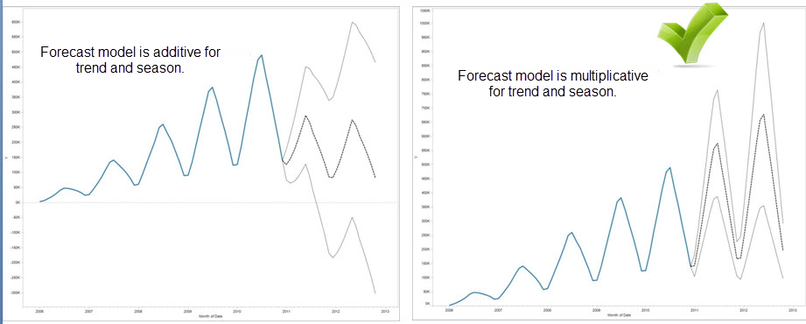

Keep in mind that you do not need to create a custom model to generate a forecast that is multiplicative: the Automatic setting can determine if a multiplicative forecast is appropriate for your data. However, a multiplicative model cannot be computed when the measure to be forecast has one or more values that are less than or equal to zero.

## Forecasting with Time

When you are forecasting with a date, there can be only one base date in the view. Part dates are supported, but all parts must refer to the same underlying field. Dates can be on Rows, Columns, or Marks (with the exception of the Tooltip target).

Tableau supports three types of dates, two of which can be used for forecasting:

* Truncated dates and reference a particular point in history with specific temporal granularity, such as February 2017. They are usually continuous, with a green background in the view. Truncated dates are valid for forecasting.
* Date parts refer to a particular member of a temporal measure such as February. Each date part is represented by a different, usually discrete field (with a blue background). Forecasting requires at least a Year date part. Specifically, it can use any of the following sets of date parts for forecasting:
  + *Year*
  + *Year + quarter*
  + *Year + month*
  + *Year + quarter + month*
  + *Year + week*
  + *Custom: Month/Year, Month/Day/Year*

Other date parts, such as *Quarter* or *Quarter + month*, are not valid for forecasting. See [Convert Fields between Discrete and Continuous](http://onlinehelp.tableau.com/current/pro/desktop/en-us/datafields_typesandroles_convertdisctocont.html) for more details about different date types.

* Exact dates refer to a particular point in history with maximum temporal granularity such as February 1, 2012 at 14:23:45.0. Exact dates are invalid for forecasting.

It is also possible to forecast without a date. See [Forecasting When No Date is in the View](http://onlinehelp.tableau.com/current/pro/desktop/en-us/forecast_no_date.html).

## Granularity and Trimming

When you create a forecast, you select a date dimension that specifies a unit of time at which date values are to be measured. Tableau dates support a range of such time units, including Year, Quarter, Month, and Day. The unit you choose for the date value is known as the *granularity* of the date.

The data in your measure typically does not align precisely with your unit of granularity. You might set your date value to quarters, but your actual data may terminate in the middle of a quarter—for example, at the end of November. This can cause a problem because the value for this fractional quarter is treated by the forecasting model as a full quarter, which will typically have a lower value than a full quarter would. If the forecasting model is allowed to consider this data, the resulting forecast will be inaccurate. The solution is to trim the data, such that the trailing periods that could mislead the forecast are ignored. Use the Ignore Last option in the Forecast Options dialog box to remove—or *trim*—such partial periods. The default is to trim one period.

## Getting More Data

Tableau requires at least five data points in the time series to estimate a trend, and enough data points for at least two seasons or one season plus five periods to estimate seasonality. For example, at least nine data points are required to estimate a model with a four quarter seasonal cycle (4 + 5), and at least 24 to estimate a model with a twelve month seasonal cycle (2 * 12).

If you turn on forecasting for a view that does not have enough data points to support a good forecast, Tableau can sometimes retrieve enough data points to produce a valid forecast by querying the datasource for a finer level of granularity:

* If your view contains fewer than nine years of data, by default, Tableau will query the data source for quarterly data, estimate a quarterly forecast, and aggregate to a yearly forecast to display in your view. If there are still not enough data points, Tableau will estimate a monthly forecast and return the aggregated yearly forecast to your view.
* If your view contains fewer than nine quarters of data, by default Tableau will estimate a monthly forecast and return the aggregated quarterly forecast results to your view.
* If your view contains fewer than nine weeks of data, by default, Tableau will estimate a daily forecast and return the aggregated weekly forecast results to your view.
* If your view contains fewer than nine days of data, by default, Tableau will estimate an hourly forecast and return the aggregated daily forecast results to your view.
* If your view contains fewer than nine hours of data, by default, Tableau will estimate an minutely forecast and return the aggregated hourly forecast results to your view.
* If your view contains fewer than nine minutes of data, by default, Tableau will estimate an secondly forecast and return the aggregated minutely forecast results to your view.

These adjustments happen behind the scene and require no configuration. Tableau does not change the appearance of your visualization, and does not actually change your date value. However, the summary of the forecast time period in the Forecast Describe and Forecast Options dialog will reflect the actual granularity used.

To Create a Forecast

Forecasting requires a view that uses at least one date dimension and one measure. For example:

* The field you want to forecast is on the **Rows** shelf and a continuous date field is on the **Columns** shelf.
* The field you want to forecast is on the **Columns** shelf and a continuous date field is on the **Rows** shelf.
* The field you want to forecast on either the **Rows** or **Columns** shelf, and discrete dates are on either the **Rows** or **Columns** shelf. At least one of the included date levels must be Year.
* The field you want to forecast is on the Marks card, and a continuous date or discrete date set is on **Rows**, **Columns** or **Marks**.

**Note**: You can also create a forecast when no date dimension is present if there is a dimension in the view that has integer values. See [Forecasting When No Date is in the View](http://onlinehelp.tableau.com/current/pro/desktop/en-us/forecast_no_date.html).

To turn forecasting on, either right-click (control-click on Mac) on the visualization and choose **Forecast >Show Forecast**, or choose **Analysis >Forecast >Show Forecast**.

With forecasting on, Tableau visualizes estimated future values of the measure, in additional to actual historical values. The estimated values are shown by default in a lighter shade of the color used for the historical data:

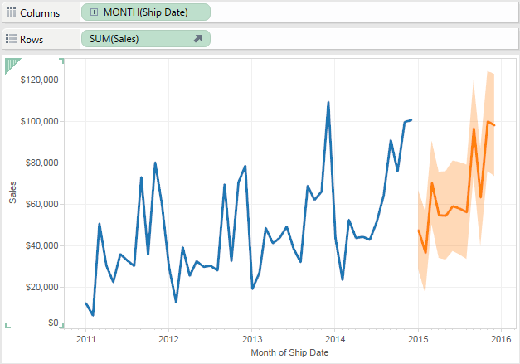

Prediction Intervals

The shaded area in the image above shows the 95% prediction interval for the forecast. That is, the model has determined that there is a 95% likelihood that the value of sales will be within the shaded area for the forecast period. You can configure the confidence level percentile for the prediction bands, and whether prediction bands are included in the forecast, using the **Show prediction intervals** setting in the Forecast Options dialog box:

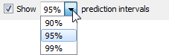

Clear the check box if you do not want to display prediction bands in forecasts. To set the prediction interval, select one of the values or enter a custom value. The lower the percentile you set for the confidence level, the narrower the prediction bands will be.

How your prediction intervals are displayed depends on the mark type of your forecasted marks:

|  |  |
| --- | --- |
| **Forecast mark type** | **Prediction intervals displayed using** |
| Line | Bands |
| Shape, square, circle, bar, or pie | Whiskers |

In the following example, forecast data is indicated by lighter shaded circles, and the prediction intervals are indicated by lines ending in whiskers:

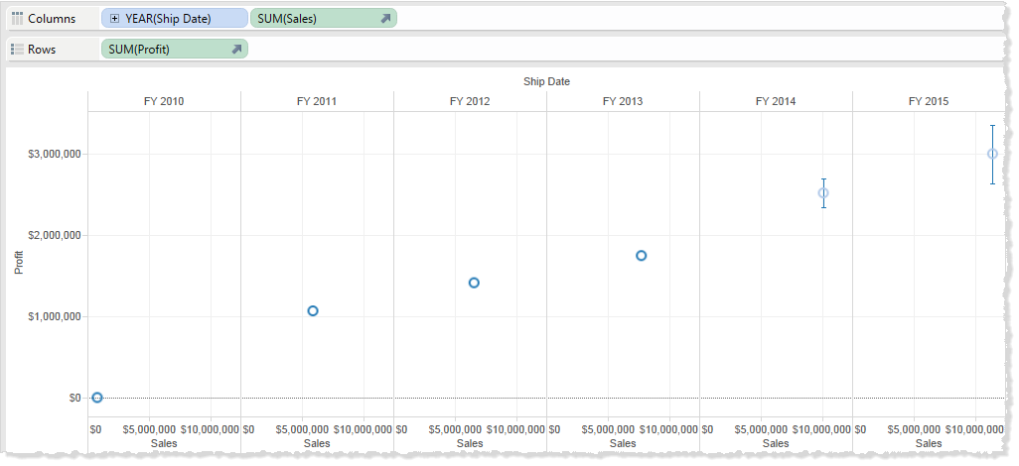

Enhancing Forecasts

For each forecast value, consider verifying the quality or precision of your forecast by dragging another instance of the forecast measure from the **Data** pane to the Detail shelf on the Marks card and then after right-clicking the field to open the content menu, choosing one of the available options:

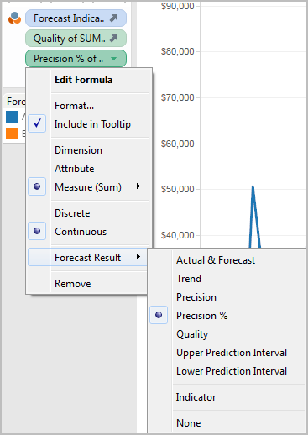

# Forecast Field Results

Tableau provides several types of forecast results. To view these result types in the view, right-click (control-click on Mac) on the measure field, choose **Forecast Result**, and then choose one of the options.

The options are:

* Actual & Forecast—Show the actual data extended by forecasted data.
* Trend—Show the forecast value with the seasonal component removed.
* Precision—Show the prediction interval distance from the forecast value for the configured confidence level.
* Precision %—Show precision as a percentage of the forecast value.
* Quality—Show the quality of the forecast, on a scale of 0 (worst) to 100 (best). This metric is scaled MASE, based on the MASE (Mean Absolute Scaled Error) of the forecast, which is the ratio of forecast error to the errors of a naïve forecast which assumes that the value of the current period will be the same as the value of the next period. The actual equation used for quality is:

http://onlinehelp.tableau.com/current/pro/desktop/en-us/GeneratedImages/Equations/Equation1.png

The Quality for a naïve forecast would be 0. The advantage of the MASE metric over the more common MAPE is that MASE is defined for time series which contain zero, wheras MAPE is not. In addition, MASE weights errors equally while MAPE weights positive and/or extreme errors more heavily.

* Upper Prediction Interval—Shows the value above which the true future value will lie confidence level percent of the time assuming a high quality model. The confidence level percentage is controlled by the Prediction Interval setting in the Forecast Options dialog box. See [Configure Forecast Options](http://onlinehelp.tableau.com/current/pro/desktop/en-us/forecast_options.html).
* Lower Prediction Interval—Shows 90, 95, or 99 confidence level below the forecast value. The actual interval is controlled by the Prediction Interval setting in the Forecast Options dialog box.
* Indicator—Show the string **Actual** for rows that were already on the worksheet when forecasting was inactive and **Estimate** for rows that were added when forecasting was activated.
* None—Do not show forecast data for this measure.

Forecast description information is also included in the worksheet description. See [Describing the View](http://onlinehelp.tableau.com/current/pro/desktop/en-us/inspectdata_describe.html).

## Forecasting a New Measure

When you add a new measure to a visualization that already has forecasting enabled, Tableau attempts to forecast future values.

## Changing the Forecast Result Type

To change the forecast result type for a measure, right-click (control-click on Mac) on the measure field, select Forecast Result, and then choose a result type.

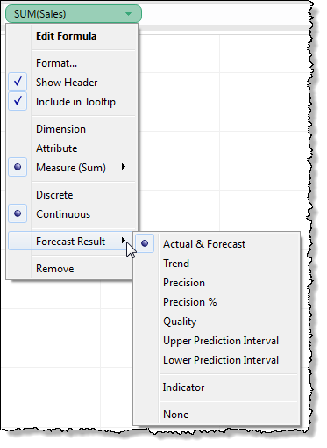

# Configure Forecast Options

Use the Forecast Options dialog box to configure forecast options, including:

* The length of the forecast
* The range and temporal aggregation of source data from which to generate the forecast
* The forecast model
* Prediction intervals

When forecasting is enabled, you can open the Forecast Options dialog box by choosing Analysis >Forecast >Forecast Options.

## Forecast Length

The Forecast Length section determines how far into the future the forecast extends. Select one of the following:

* Automatic: Tableau determines the forecast length based on the data.
* Exactly: Extends the forecast for the specified number of units.
* Until: Extends the forecast to the specified point in the future.

## Source Data

Use the Source Data section to specify.

* Aggregate by: Specifies the temporal granularity of the time series. With the default value (Automatic), Tableau chooses the best granularity for estimation. This will typically match the temporal granularity of the visualization (that is, the date dimension that the forecast is based on). However, it is sometimes possible and desirable to estimate the forecast model at a finer granularity than the visualization when the time series in the visualization is too short to allow estimation.

**Note**: When you are using an integer dimension instead of a date dimension for forecasting, the Aggregate by value is always Periods. See [Forecasting When No Date is in the View](http://onlinehelp.tableau.com/current/pro/desktop/en-us/forecast_no_date.html).

* Ignore last: Specifies the number of periods at the end of the actual data that should be ignored in estimating the forecast model. Forecast data is used instead of actual data for these time periods. Use this feature to trim off unreliable or partial trailing periods which could mislead the forecast. When the estimation granularity specified in the **Source Data** section is finer than in the visualization, the trimmed periods are estimation periods. As a result, the trailing actual visualization period may become a forecast period, which is an aggregate of both actual and forecast periods of estimation granularity. In contrast, null values are not filled with zeros and must be filtered to allow forecast.
* Fill in missing values with zeros: If there are missing values in the measure you are attempting to forecast, you can specify that Tableau fill in these missing values with zero.

## Forecast Model

The Forecast Model section specifies how the forecast model is to be produced.

Use the drop down to specify whether Tableau selects what it determines to be the best of all models (Automatic), the best of those with no seasonal component (Automatic without seasonality), or the model you specify (Custom).

When you choose the Custom option, two new fields appear in the Forecast Options dialog box, which you use to specify the trend and season characteristics for your model:



The choices are the same for both fields:

* None: When you select None for Trend, the model does not assess the data for trend. When you select None for Season, the model does not assess the data for seasonality.
* Additive: An additive model is one in which the combined effect of several independent factors is the sum of the isolated effects of each factor. You can assess the data in your view for additive trend, additive seasonality, or both.
* Multiplicative : A multiplicative model is one in which the combined effect of several independent factors is the product of the isolated effects of each factor. You can assess the data in your view for multiplicative trend, multiplicative seasonality, or both.

If there is more than one time series in your visualization, the Custom option forces them all to be forecast using the same custom model. Constraining the models in this way usually results in lower quality models than would be produced by automatic model selection.

### Constraints on Multiplicative Models

* You cannot use a multiplicative model when the measure to be forecast has one or more values that are less than or equal to zero, or even when some of the data points are too close to zero, relative to other data points.
* You cannot specify a model with multiplicative trend and additive season because the result may be numerically unstable.

## Prediction Interval

You can set the prediction interval to 90, 95, or 99 percent, or enter a custom value. This value is used in two locations:

* In the prediction bands displayed with a forecast.
* For the prediction interval options (Upper Prediction Interval and Lower Prediction Interval) that are available as forecast result types for a measure in the view:



# Forecast Descriptions

The Describe Forecast dialog box describes the forecast models that Tableau computed for your visualization. When forecasting is enabled, you can open this dialog by selecting Analysis >Forecast >Describe Forecast. The information in the Describe Forecast dialog box is read-only, though you can click Copy to Clipboard and then paste the screen contents into a writeable document.

The Describe Forecast dialog box has two tabs: a Summary tab and a Models tab.

## Describe Forecast – Summary Tab

The Summary tab describes the forecast models Tableau has created, as well as the general patterns Tableau discovered in the data.

### Options Used To Create Forecasts

This section summarizes the options Tableau used to create forecasts. These options were either picked automatically by Tableau or specified in the Forecast Options dialog box.

* Time series—The continuous date field used to define the time series. In some cases this value might not actually be a date. See [Forecasting When No Date is in the View](http://onlinehelp.tableau.com/current/pro/desktop/en-us/forecast_no_date.html).
* Measures—The measures for which values are estimated.
* Forecast forward—The length and date range of the forecast.
* Forecast based on—The date range of the actual data used to create the forecast.
* Ignore last—The number of periods at the end of the actual data that are disregarded--forecast data is displayed for these periods.This value is determined by the Ignore Last option in the Forecast Options dialog box.
* Seasonal pattern—The length of the seasonal cycle that Tableau found in the data, or None if no seasonal cycle was found in any forecast.

### Forecast Summary Tables

For each measure that is forecasted, a summary table is displayed describing the forecast. If the view is broken into multiple panes using dimensions, a column is inserted into each table that identifies the dimensions. The fields in summary forecast tables are:

* Initial—The value and prediction interval of the first forecast period.
* Change From Initial—The difference between the first and the last forecast estimate points. The interval for those two points is shown in the column header. When values are shown as percentages, this field shows the percentage change from the first forecast period.
* Seasonal Effect—These fields are displayed for models identified as having seasonality--that is, a repeating pattern of variation over time. They show the high and low value of the seasonal component of the last full seasonal cycle in the combined time series of actual and forecast values. The seasonal component expresses the deviation from the trend and so varies around zero and sums to zero over the course of a season.
* Contribution—The extent to which Trend and Seasonality contribute to the forecast. These values are always expressed as percentages and add up to 100%.
* Quality—Indicates how well the forecast fits the actual data. Possible values are GOOD, OK, and POOR. A naïve forecast is defined as a forecast that estimates that the value of the next period will be identical to the value of the current period. Quality is expressed relative to a naïve forecast, such that OK means the forecast is likely to have less error than a naïve forecast, GOOD means that the forecast has less than half as much error, and POOR means that the forecast has more error.

## Describe Forecast – Models Tab

The Models tab provides more exhaustive statistics and smoothing coefficient values for the Holt-Winters exponential smoothing models underlying the forecasts. For each measure that is forecasted, a table is displayed describing the forecast models Tableau created for the measure. If the view is broken into multiple panes using dimensions, a column is inserted into each table that identifies the dimensions. The table is organized into the following sections:

### Model

Specifies whether the components Level, Trend, or Season are part of the model used to generate the forecast. The value for each component is one of the following:

* None—The component is not present in the model.
* Additive—The component is present and is added to the other components to create the overall forecast value.
* Multiplicative—The component is present and is multiplied by the other components to create the overall forecast value.

### Quality Metrics

This set of values provides statistical information about the quality of the model.

|  |  |
| --- | --- |
| **Value** | **Definition** |
| RMSE: Root mean squared error | http://onlinehelp.tableau.com/current/pro/desktop/en-us/GeneratedImages/Equations/Equation2.png |
| MAE: Mean absolute error | http://onlinehelp.tableau.com/current/pro/desktop/en-us/GeneratedImages/Equations/Equation3.png |
| MASE: Mean absolute scaled error.  MASE measures the magnitude of the error compared to the magnitude of the error of a naive one-step ahead forecast as a ratio. A naive forecast assumes that whatever the value is today will be same value tomorrow. So, a MASE of 0.5 means that your forecast is likely to have half as much error as a naive forecast, which is better than a MASE of 1.0, which is no better than a naive forecast. Since this is a normalized statistic that is defined for all values and weighs errors evenly, it is an excellent metric for comparing the quality of different forecast methods.  The advantage of MASE over the more common MAPE metric is that MASE is defined for time series that contain zero, whereas MAPE is not. Also, MASE weights errors equally, whereas MAPE weights positive and/or extreme errors more heavily. | http://onlinehelp.tableau.com/current/pro/desktop/en-us/GeneratedImages/Equations/Equation4.png |
| MAPE: Mean absolute percentage error.  MAPE measures the magnitude of the error compared to the magnitude of your data, as a percentage. So, a MAPE of 20% is better than a MAPE of 60%. Errors are the differences between the response values, which the model estimates, and the actual response values for each explanatory value in your data. Since this is a normalized statistic, it can be used to compare the quality of different models computed in Tableau. However, it is unreliable for some comparisons because it weights some kinds of error more heavily than others. Also, it is undefined for data with values of zero. | http://onlinehelp.tableau.com/current/pro/desktop/en-us/GeneratedImages/Equations/Equation5.png |
| AIC: Akaike information criterion.  AIC is a model quality measure, developed by Hirotugu Akaike, that penalizes complex models to prevent overfitting. In this definition, *k* is the number of estimated parameters, including initial states, and *SSE* is the sum of the squared errors. | AIC definition |

In the preceding definitions, the variables are as follow:

|  |  |
| --- | --- |
| **Variable** | **Meaning** |
| t | Index of a period in a time series. |
| n | Time series length. |
| m | Number of periods in a season/cycle. |
| A(t) | Actual value of the time series at period t. |
| F(t) | Fitted or forecast value at period t. |

Residuals are: e(t) = F(t)-A(t)

### Smoothing Coefficients

Depending on the rate of evolution in the level, trend, or seasonal components of the data, smoothing coefficients are optimized to weight more recent data values over older ones, such that within-sample one-step-ahead forecast errors are minimized. Alpha is the level smoothing coefficient, beta the trend smoothing coefficient, and gamma the seasonal smoothing coefficient. The closer a smoothing coefficient is to 1.00, the less smoothing is performed, allowing for rapid component changes and heavy reliance on recent data. The closer a smoothing coefficient is to 0.00, the more smoothing is performed, allowing for gradual component changes and less reliance on recent data.